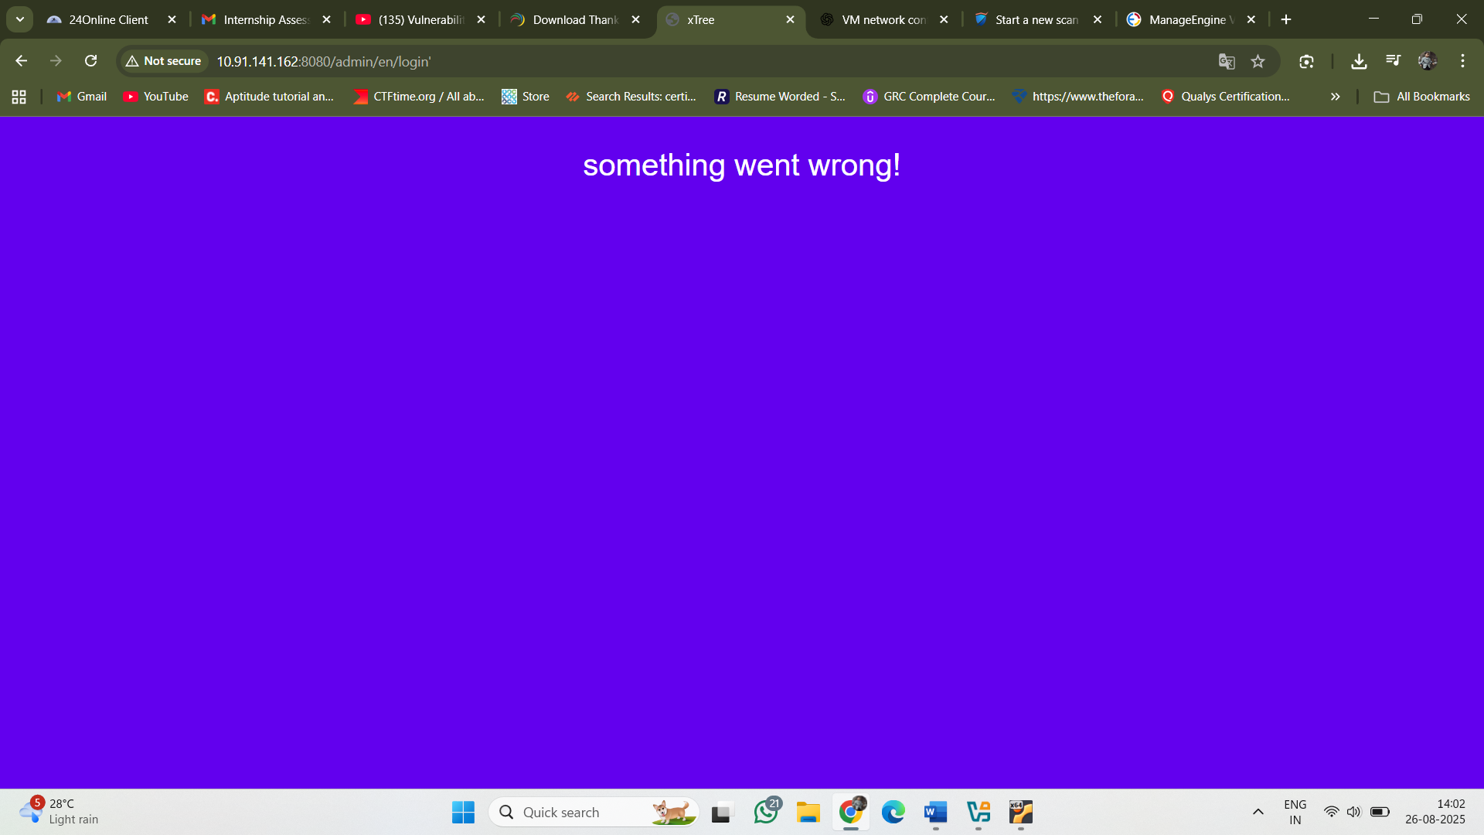

👍 —
From your link:
http://localhost:8020/webclient#/uems/patch-mgmt/systems/scan-systems
using ManageEngine Endpoint Central (formerly Desktop Central), which has patch & vulnerability management built in.

🔧 Steps to Add Your VM for Vulnerability Scanning

1️⃣ Make Sure Your VM is Reachable
- First confirm your VM (Ubuntu xbersec) has an IP your host can reach:
- ifconfig
Example: 192.168.190.5 (if Host-only) or 192.168.1.105 (if Bridged).
- From your host machine, try:
- ping 192.168.190.5
If ping works, you’re good.

2️⃣ Enable Required Services on VM
The VMS usually connects over:
- SSH (Linux) → port 22 must be open
- WMI/SMB (Windows) → ports 135, 445, etc.
Since your VM is Ubuntu, make sure openssh-server is installed:
sudo apt update
sudo apt install openssh-server -y
sudo systemctl enable ssh
sudo systemctl start ssh

3️⃣ Add the VM in Endpoint Central (VMS)
- Open your console:
- http://localhost:8020/webclient#/uems/patch-mgmt/systems/scan-systems
- Go to Patch Management → Systems → Scan Systems.
- Click Add Systems (or Import).
- Enter:
  - IP Address / Range: the VM IP (192.168.190.5)
  - OS Type: Linux
  - Authentication: provide the SSH login credentials (username = xbersec, password = qwerty@123).
- Save & start a scan.
  - The VMS will connect over SSH and enumerate installed packages, configs, and vulnerabilities.

4️⃣ Verify the Webserver is Detected
Since your vulnerable app runs on port 8080, you might also want to:
- Check if the VMS scans web applications on open ports.
- If not, you may need to run a separate web vulnerability scanner (like OWASP ZAP, Nikto, or Burp Suite) against http://192.168.190.5:8080.

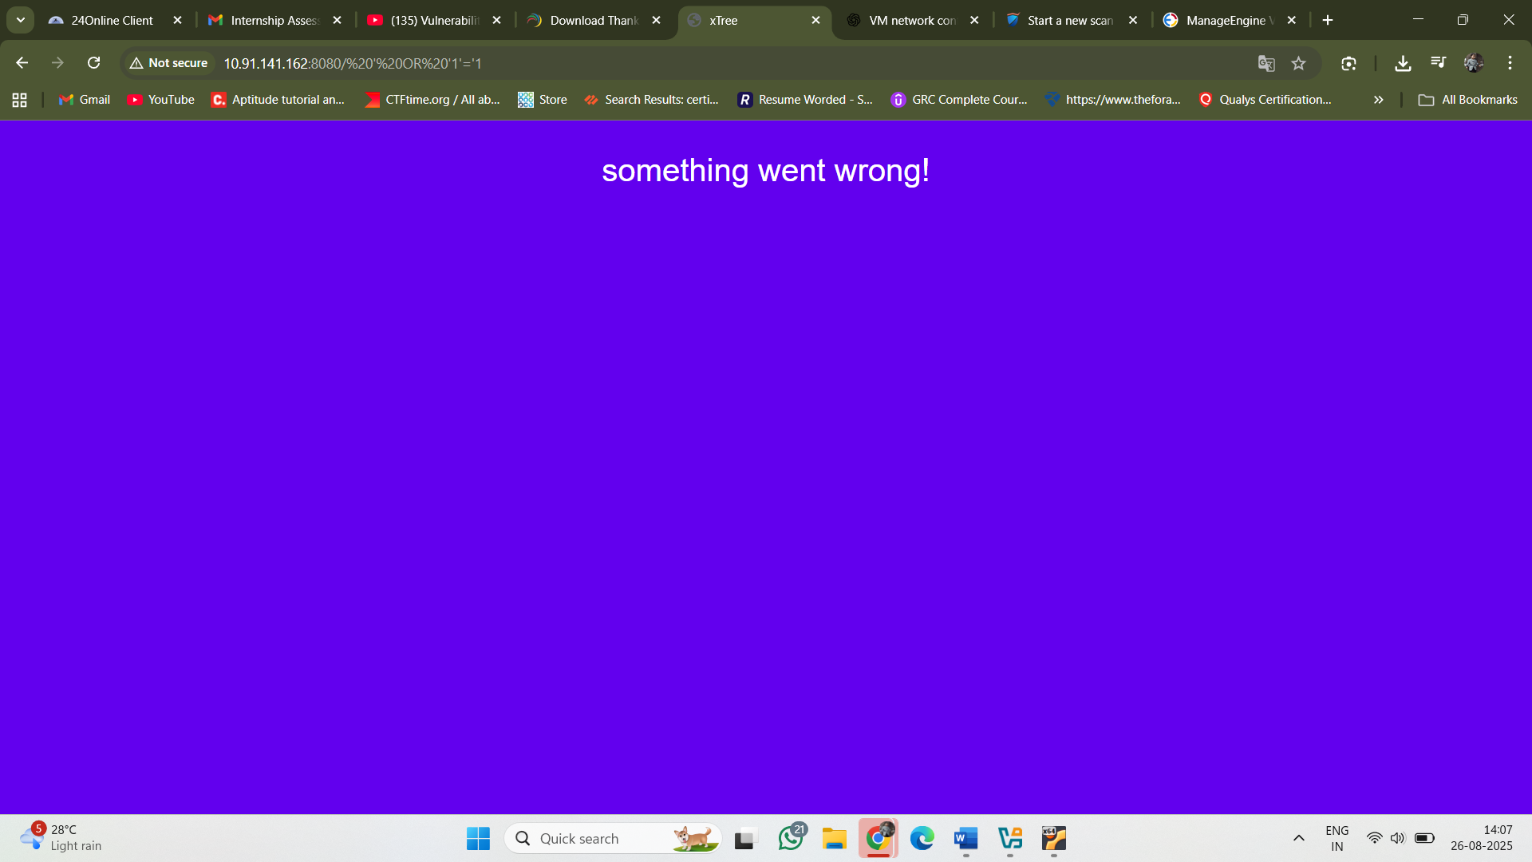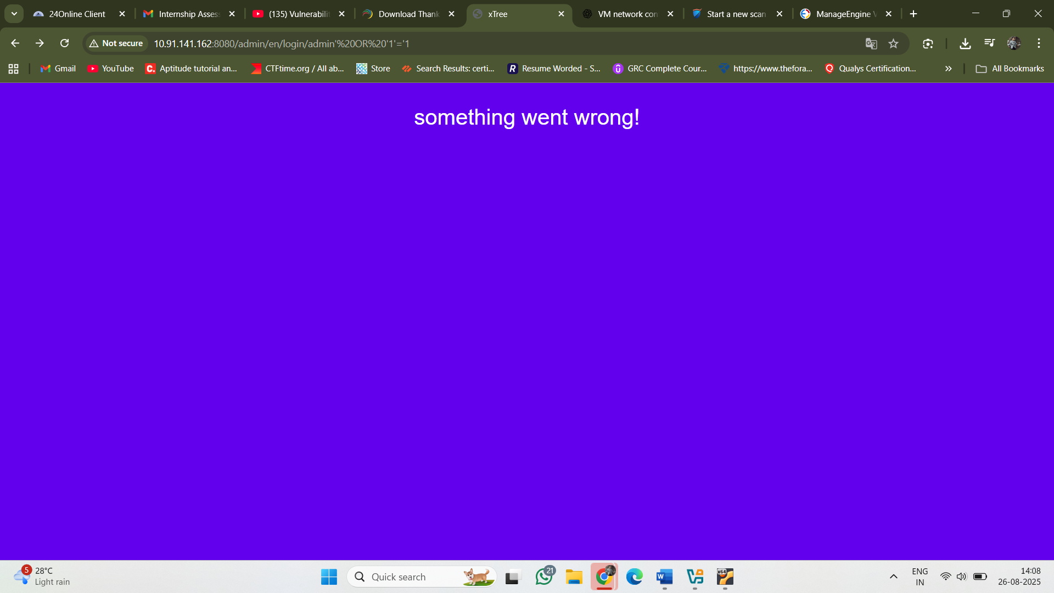
- Sql injection when I give single quotation and 1=1 the web server communicate with me
Instead of throw a error like 404 status error something

